**第一课 学校有多少学生**

1. 描一描，写一写

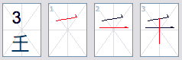

|  |  |  |  |
| --- | --- | --- | --- |
| 千 |  |  |  |
| 千 |  |  |  |
| 千 |  |  |  |

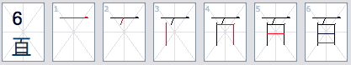

|  |  |  |  |  |  |  |
| --- | --- | --- | --- | --- | --- | --- |
| 百 |  |  |  |  |  |  |
| 百 |  |  |  |  |  |  |
| 百 |  |  |  |  |  |  |



|  |  |  |  |  |  |  |  |  |  |  |  |  |  |
| --- | --- | --- | --- | --- | --- | --- | --- | --- | --- | --- | --- | --- | --- |
| 楼 |  |  |  |  |  |  |  |  |  |  |  |  |  |
| 楼 |  |  |  |  |  |  |  |  |  |  |  |  |  |
| 楼 |  |  |  |  |  |  |  |  |  |  |  |  |  |

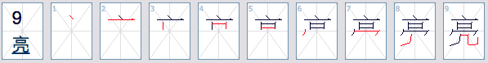

|  |  |  |  |  |  |  |  |  |  |
| --- | --- | --- | --- | --- | --- | --- | --- | --- | --- |
| 亮 |  |  |  |  |  |  |  |  |  |
| 亮 |  |  |  |  |  |  |  |  |  |
| 亮 |  |  |  |  |  |  |  |  |  |

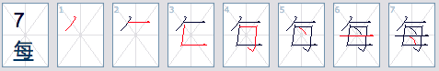

|  |  |  |  |  |  |  |  |
| --- | --- | --- | --- | --- | --- | --- | --- |
| 每 |  |  |  |  |  |  |  |
| 每 |  |  |  |  |  |  |  |
| 每 |  |  |  |  |  |  |  |

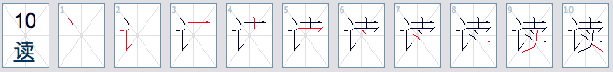

|  |  |  |  |  |  |  |  |  |  |  |
| --- | --- | --- | --- | --- | --- | --- | --- | --- | --- | --- |
| 读 |  |  |  |  |  |  |  |  |  |  |
| 读 |  |  |  |  |  |  |  |  |  |  |
| 读 |  |  |  |  |  |  |  |  |  |  |

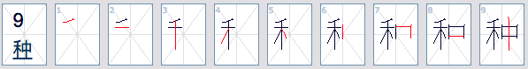

|  |  |  |  |  |  |  |  |  |  |
| --- | --- | --- | --- | --- | --- | --- | --- | --- | --- |
| 种 |  |  |  |  |  |  |  |  |  |
| 种 |  |  |  |  |  |  |  |  |  |
| 种 |  |  |  |  |  |  |  |  |  |

1. 读汉字并用拼音写下来

|  |
| --- |
| 1. 这条裙子十五万五千盾。 |
| 拼音： |

|  |
| --- |
| 2. 我家门前种了很多花。 |
| 拼音： |

|  |
| --- |
| 3. 我们学校一共有五十位老师。 |
| 拼音： |

|  |
| --- |
| 4. 教学楼里有很多明亮的教室。 |
| 拼音： |

|  |
| --- |
| 5. 每天晚上我读一个故事。 |
| 拼音： |

|  |
| --- |
| 6. 今天，我们一起在校园里种树，这个活动真有意思。 |
| 拼音： |
|  |

1. 请以（学校有多少学生）为题，写一篇200字左右的文章

|  |  |  |  |  |  |  |  |  |  |  |  |  |  |  |  |  |  |  |  |
| --- | --- | --- | --- | --- | --- | --- | --- | --- | --- | --- | --- | --- | --- | --- | --- | --- | --- | --- | --- |
|  |  |  |  |  |  |  |  |  |  |  |  |  |  |  |  |  |  |  |  |
|  |  |  |  |  |  |  |  |  |  |  |  |  |  |  |  |  |  |  |  |
|  |  |  |  |  |  |  |  |  |  |  |  |  |  |  |  |  |  |  |  |
|  |  |  |  |  |  |  |  |  |  |  |  |  |  |  |  |  |  |  |  |
|  |  |  |  |  |  |  |  |  |  |  |  |  |  |  |  |  |  |  |  |
|  |  |  |  |  |  |  |  |  |  |  |  |  |  |  |  |  |  |  |  |
|  |  |  |  |  |  |  |  |  |  |  |  |  |  |  |  |  |  |  |  |
|  |  |  |  |  |  |  |  |  |  |  |  |  |  |  |  |  |  |  |  |
|  |  |  |  |  |  |  |  |  |  |  |  |  |  |  |  |  |  |  |  |
|  |  |  |  |  |  |  |  |  |  |  |  |  |  |  |  |  |  |  |  |
|  |  |  |  |  |  |  |  |  |  |  |  |  |  |  |  |  |  |  |  |
|  |  |  |  |  |  |  |  |  |  |  |  |  |  |  |  |  |  |  |  |
|  |  |  |  |  |  |  |  |  |  |  |  |  |  |  |  |  |  |  |  |
|  |  |  |  |  |  |  |  |  |  |  |  |  |  |  |  |  |  |  |  |
|  |  |  |  |  |  |  |  |  |  |  |  |  |  |  |  |  |  |  |  |
|  |  |  |  |  |  |  |  |  |  |  |  |  |  |  |  |  |  |  |  |
|  |  |  |  |  |  |  |  |  |  |  |  |  |  |  |  |  |  |  |  |
|  |  |  |  |  |  |  |  |  |  |  |  |  |  |  |  |  |  |  |  |
|  |  |  |  |  |  |  |  |  |  |  |  |  |  |  |  |  |  |  |  |

1. 用汉语写出下列数目

|  |
| --- |
| 1). 70,085 |
| 汉语： |
|  |

|  |
| --- |
| 2). 36,859 |
| 汉语： |
|  |

|  |
| --- |
| 3). 40,607 |
| 汉语： |
|  |

|  |
| --- |
| 4). 42,008 |
| 汉语： |
|  |

|  |
| --- |
| 5). 653,789 |
| 汉语： |
|  |

|  |
| --- |
| 6). 270,953 |
| 汉语： |
|  |

|  |
| --- |
| 7). 794,002 |
| 汉语： |
|  |

|  |
| --- |
| 8). 304,093 |
| 汉语： |
|  |