**第一课 这双筷子是爷爷的**

1. 描一描，写一写

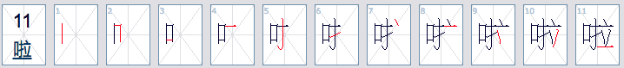

|  |  |  |  |  |  |  |  |  |  |  |  |
| --- | --- | --- | --- | --- | --- | --- | --- | --- | --- | --- | --- |
| 啦 |  |  |  |  |  |  |  |  |  |  |  |
| 啦 |  |  |  |  |  |  |  |  |  |  |  |
| 啦 |  |  |  |  |  |  |  |  |  |  |  |

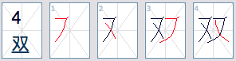

|  |  |  |  |  |
| --- | --- | --- | --- | --- |
| 双 |  |  |  |  |
| 双 |  |  |  |  |
| 双 |  |  |  |  |



|  |  |  |  |  |  |  |  |  |  |  |  |  |  |
| --- | --- | --- | --- | --- | --- | --- | --- | --- | --- | --- | --- | --- | --- |
| 筷 |  |  |  |  |  |  |  |  |  |  |  |  |  |
| 筷 |  |  |  |  |  |  |  |  |  |  |  |  |  |
| 筷 |  |  |  |  |  |  |  |  |  |  |  |  |  |

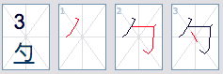

|  |  |  |  |
| --- | --- | --- | --- |
| 勺 |  |  |  |
| 勺 |  |  |  |
| 勺 |  |  |  |

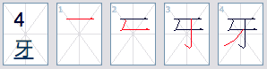

|  |  |  |  |  |
| --- | --- | --- | --- | --- |
| 牙 |  |  |  |  |
| 牙 |  |  |  |  |
| 牙 |  |  |  |  |

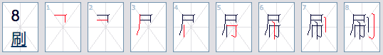

|  |  |  |  |  |  |  |  |  |
| --- | --- | --- | --- | --- | --- | --- | --- | --- |
| 刷 |  |  |  |  |  |  |  |  |
| 刷 |  |  |  |  |  |  |  |  |
| 刷 |  |  |  |  |  |  |  |  |

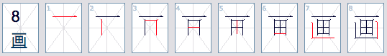

|  |  |  |  |  |  |  |  |  |
| --- | --- | --- | --- | --- | --- | --- | --- | --- |
| 画 |  |  |  |  |  |  |  |  |
| 画 |  |  |  |  |  |  |  |  |
| 画 |  |  |  |  |  |  |  |  |



|  |  |  |  |  |  |  |  |  |  |  |  |  |  |
| --- | --- | --- | --- | --- | --- | --- | --- | --- | --- | --- | --- | --- | --- |
| 碗 |  |  |  |  |  |  |  |  |  |  |  |  |  |
| 碗 |  |  |  |  |  |  |  |  |  |  |  |  |  |
| 碗 |  |  |  |  |  |  |  |  |  |  |  |  |  |

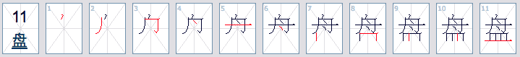

|  |  |  |  |  |  |  |  |  |  |  |  |
| --- | --- | --- | --- | --- | --- | --- | --- | --- | --- | --- | --- |
| 盘 |  |  |  |  |  |  |  |  |  |  |  |
| 盘 |  |  |  |  |  |  |  |  |  |  |  |
| 盘 |  |  |  |  |  |  |  |  |  |  |  |

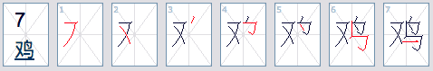

|  |  |  |  |  |  |  |  |
| --- | --- | --- | --- | --- | --- | --- | --- |
| 鸡 |  |  |  |  |  |  |  |
| 鸡 |  |  |  |  |  |  |  |
| 鸡 |  |  |  |  |  |  |  |

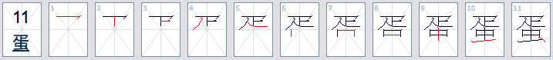

|  |  |  |  |  |  |  |  |  |  |  |  |
| --- | --- | --- | --- | --- | --- | --- | --- | --- | --- | --- | --- |
| 蛋 |  |  |  |  |  |  |  |  |  |  |  |
| 蛋 |  |  |  |  |  |  |  |  |  |  |  |
| 蛋 |  |  |  |  |  |  |  |  |  |  |  |

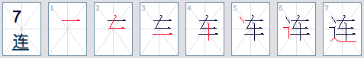

|  |  |  |  |  |  |  |  |  |  |  |  |
| --- | --- | --- | --- | --- | --- | --- | --- | --- | --- | --- | --- |
| 连 |  |  |  |  |  |  |  |  |  |  |  |
| 连 |  |  |  |  |  |  |  |  |  |  |  |
| 连 |  |  |  |  |  |  |  |  |  |  |  |

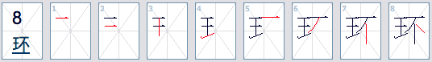

|  |  |  |  |  |  |  |  |  |
| --- | --- | --- | --- | --- | --- | --- | --- | --- |
| 环 |  |  |  |  |  |  |  |  |
| 环 |  |  |  |  |  |  |  |  |
| 环 |  |  |  |  |  |  |  |  |

1. 读汉字并用拼音写下来

|  |
| --- |
| 1. 这双筷子是爸爸的。 |
| 拼音： |

|  |
| --- |
| 2. 那本书是谁的？ |
| 拼音： |

|  |
| --- |
| 3. 妹妹不用筷子。 |
| 拼音： |

|  |
| --- |
| 4. 那个杯子是妈妈的？ |
| 拼音： |

|  |
| --- |
| 5. 这个碗是你的吗？ |
| 拼音： |

1. 请以（我的餐具）为题，写一篇80字左右的文章

|  |  |  |  |  |  |  |  |  |  |  |  |  |  |  |  |  |  |  |  |
| --- | --- | --- | --- | --- | --- | --- | --- | --- | --- | --- | --- | --- | --- | --- | --- | --- | --- | --- | --- |
|  |  |  |  |  |  |  |  |  |  |  |  |  |  |  |  |  |  |  |  |
|  |  |  |  |  |  |  |  |  |  |  |  |  |  |  |  |  |  |  |  |
|  |  |  |  |  |  |  |  |  |  |  |  |  |  |  |  |  |  |  |  |
|  |  |  |  |  |  |  |  |  |  |  |  |  |  |  |  |  |  |  |  |
|  |  |  |  |  |  |  |  |  |  |  |  |  |  |  |  |  |  |  |  |
|  |  |  |  |  |  |  |  |  |  |  |  |  |  |  |  |  |  |  |  |
|  |  |  |  |  |  |  |  |  |  |  |  |  |  |  |  |  |  |  |  |
|  |  |  |  |  |  |  |  |  |  |  |  |  |  |  |  |  |  |  |  |
|  |  |  |  |  |  |  |  |  |  |  |  |  |  |  |  |  |  |  |  |
|  |  |  |  |  |  |  |  |  |  |  |  |  |  |  |  |  |  |  |  |
|  |  |  |  |  |  |  |  |  |  |  |  |  |  |  |  |  |  |  |  |
|  |  |  |  |  |  |  |  |  |  |  |  |  |  |  |  |  |  |  |  |
|  |  |  |  |  |  |  |  |  |  |  |  |  |  |  |  |  |  |  |  |
|  |  |  |  |  |  |  |  |  |  |  |  |  |  |  |  |  |  |  |  |
|  |  |  |  |  |  |  |  |  |  |  |  |  |  |  |  |  |  |  |  |
|  |  |  |  |  |  |  |  |  |  |  |  |  |  |  |  |  |  |  |  |