**第一课 这是我的书**

1. 描一描，写一写

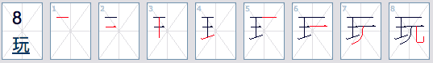

|  |  |  |  |  |  |  |  |  |
| --- | --- | --- | --- | --- | --- | --- | --- | --- |
| 玩 |  |  |  |  |  |  |  |  |
| 玩 |  |  |  |  |  |  |  |  |
| 玩 |  |  |  |  |  |  |  |  |

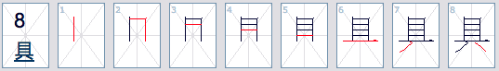

|  |  |  |  |  |  |  |  |  |
| --- | --- | --- | --- | --- | --- | --- | --- | --- |
| 具 |  |  |  |  |  |  |  |  |
| 具 |  |  |  |  |  |  |  |  |
| 具 |  |  |  |  |  |  |  |  |

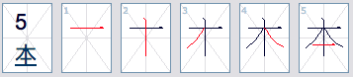

|  |  |  |  |  |  |
| --- | --- | --- | --- | --- | --- |
| 本 |  |  |  |  |  |
| 本 |  |  |  |  |  |
| 本 |  |  |  |  |  |

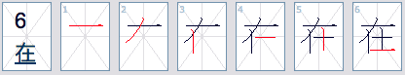

|  |  |  |  |  |  |  |
| --- | --- | --- | --- | --- | --- | --- |
| 在 |  |  |  |  |  |  |
| 在 |  |  |  |  |  |  |
| 在 |  |  |  |  |  |  |

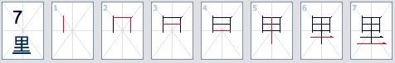

|  |  |  |  |  |  |  |  |
| --- | --- | --- | --- | --- | --- | --- | --- |
| 里 |  |  |  |  |  |  |  |
| 里 |  |  |  |  |  |  |  |
| 里 |  |  |  |  |  |  |  |

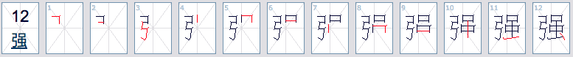

|  |  |  |  |  |  |  |  |  |  |  |  |  |
| --- | --- | --- | --- | --- | --- | --- | --- | --- | --- | --- | --- | --- |
| 强 |  |  |  |  |  |  |  |  |  |  |  |  |
| 强 |  |  |  |  |  |  |  |  |  |  |  |  |
| 强 |  |  |  |  |  |  |  |  |  |  |  |  |

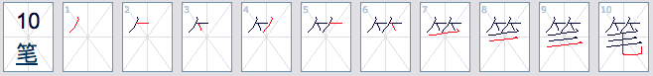

|  |  |  |  |  |  |  |  |  |  |  |
| --- | --- | --- | --- | --- | --- | --- | --- | --- | --- | --- |
| 笔 |  |  |  |  |  |  |  |  |  |  |
| 笔 |  |  |  |  |  |  |  |  |  |  |
| 笔 |  |  |  |  |  |  |  |  |  |  |

1. 读汉字并用拼音写下来

|  |
| --- |
| 1. 这是谁的书？ |
| 拼音： |

|  |
| --- |
| 2. 这是我的书包。 |
| 拼音： |

|  |
| --- |
| 3. 那是谁的笔？ |
| 拼音： |

|  |
| --- |
| 4. 那是小丽的本子。 |
| 拼音： |

|  |
| --- |
| 5. 他是小华的姐姐 |
| 拼音： |

1. 请以（我的书包）为题，写一篇100字左右的文章

|  |  |  |  |  |  |  |  |  |  |  |  |  |  |  |  |  |  |  |  |
| --- | --- | --- | --- | --- | --- | --- | --- | --- | --- | --- | --- | --- | --- | --- | --- | --- | --- | --- | --- |
|  |  |  |  |  |  |  |  |  |  |  |  |  |  |  |  |  |  |  |  |
|  |  |  |  |  |  |  |  |  |  |  |  |  |  |  |  |  |  |  |  |
|  |  |  |  |  |  |  |  |  |  |  |  |  |  |  |  |  |  |  |  |
|  |  |  |  |  |  |  |  |  |  |  |  |  |  |  |  |  |  |  |  |
|  |  |  |  |  |  |  |  |  |  |  |  |  |  |  |  |  |  |  |  |
|  |  |  |  |  |  |  |  |  |  |  |  |  |  |  |  |  |  |  |  |
|  |  |  |  |  |  |  |  |  |  |  |  |  |  |  |  |  |  |  |  |
|  |  |  |  |  |  |  |  |  |  |  |  |  |  |  |  |  |  |  |  |
|  |  |  |  |  |  |  |  |  |  |  |  |  |  |  |  |  |  |  |  |
|  |  |  |  |  |  |  |  |  |  |  |  |  |  |  |  |  |  |  |  |
|  |  |  |  |  |  |  |  |  |  |  |  |  |  |  |  |  |  |  |  |
|  |  |  |  |  |  |  |  |  |  |  |  |  |  |  |  |  |  |  |  |
|  |  |  |  |  |  |  |  |  |  |  |  |  |  |  |  |  |  |  |  |
|  |  |  |  |  |  |  |  |  |  |  |  |  |  |  |  |  |  |  |  |
|  |  |  |  |  |  |  |  |  |  |  |  |  |  |  |  |  |  |  |  |
|  |  |  |  |  |  |  |  |  |  |  |  |  |  |  |  |  |  |  |  |