Robotic Toast

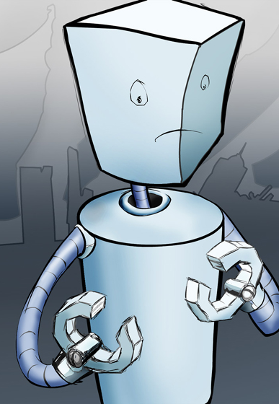
Robbie is a self-programming robot. However, being a cheap robot, he is easily confused and often struggles to make toast. Help Robbie create a program to make two perfect slices of toast.

Instructions:

- Remove toast from toaster
- Wait two minutes
- Push down handle
- Insert two slices of bread in toaster

Start
End

