名字 ：
班级 ：

- Please write the stroke order for the Chinese character
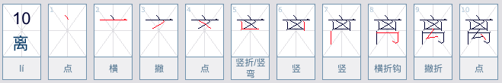

离
离
离
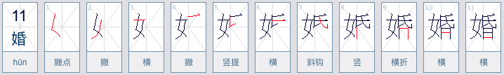

婚
婚
婚

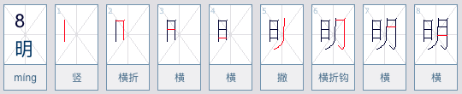

明
明
明
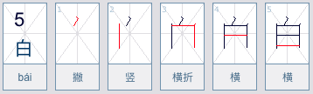

白
白
白
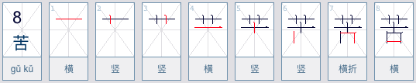

苦
苦
苦

想
婚
婚
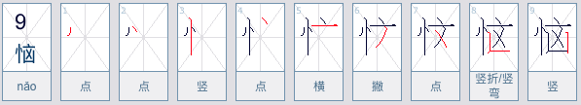

恼
恼
恼

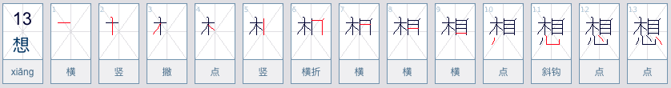

念
念
念
